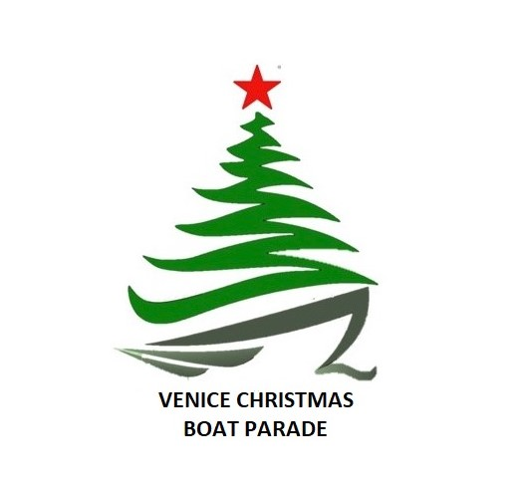
Venice Christmas Boat Parade
PO Box 1165
Venice, FL 34284-1165
www.venicechristmasboatparade.com

Officers

President
Joe Zgrzepski
joezgrzepski@gmail.com

Vice President
Patty Bozek
pbozek4935@gmail.com

Treasurer
Tom Whittaker
Dowd Whittaker & Assoc., CPA’s
tom@dowdwhittaker.com

Secretary
Kristi Zgrzepski
jkfarmz28@yahoo.com

Board Members

Jeff & Tania Koch
jtkoch@yahoo.com

2022
Venice Christmas Boat Parade

The Parade Committee cordially invites you to be a sponsor of the Venice Christmas Boat Parade on the Intracoastal Waterways of Venice, FL. The Parade is scheduled every year for the 1st Saturday in December starting at 6pm, the route beginning north of Albee Road and traveling down to and returning at the Circus Bridge.

When Jim Hussman and a group of Venice residents decided to start the Boat Parade 33 years ago, and was maintained for 14 years under the direction of John Osmulski, no one realized that this annual activity of Giving Back to the Community would generate the thousands of people who view and appreciate the parade on a yearly basis. Under the leadership of the new President Joe Zgrzepski, the parade board and volunteers, the enthusiasm of our boating participants and the contributions from our area sponsors, the parade continues to be an anticipated yearly event to celebrate and enjoy the holidays. Spectators of all ages stake out their viewing position days before the parade begins and parties are planned along the waterway.

A significant portion of funding for the parade depends on sponsorships from individuals, organizations, and businesses in the community.

The Venice Christmas Boat Parade is a 501(c)(3) – not for profit, so your donation is a tax savings to you while filling a need for the area. Our sponsors will enable the Boat Parade Committee to meet those associated parade costs and fund various activities in our community such as, the Venice Boy Scouts, Venice Youth Boating, Venice HS scholarship, All Faith Food Bank, and St. Francis Rescue, to name a few.

The success of the Venice Christmas Boat Parade is made possible through your generosity. We hope we can count on your support as a sponsor.

If you have any questions, or if you would like further information, please do not hesitate to contact Joe Zgrzepski at joezgrzepski@gmail.com or
call 941-718-8644. You may also visit the web site for parade information at www.venicechristmasboatparade.com or visit us on Facebook at www.facebook.com/VeniceChristmasBoatParade/.

Sincerely,
Venice Christmas Boat Parade Committee

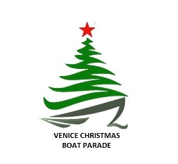

RESPONSE FORM

Name of Organization: _____________________________________________________________

Contact Name: ____________________________________________________________________
Address for Correspondence: ________________________________________________________
e-mail Address: ___________________________________________________________________
Phone #’s: _______________________________________________________________________
Sponsorship Level: ________________________________________________________________
Signature/Title: __________________________________________________________________

Please attach a copy of your Organizations’ Logo; either a business card or stationary which has a crisp view of your logo.

Please mail this form and your donation to:

Venice Christmas Boat Parade, Inc.
PO Box 1165
Venice, FL 34284-1165

